CENTRAL OKANAGAN
DISTRICT AUTHORITY SCHOLARSHIPS
STUDENT INFORMATION
2019/20

The District Authority Scholarships reward graduating BC students for excellence in their chosen area of skill and or passion. A student who wins a District Authority Scholarship will be mailed a congratulatory letter, a certificate and a voucher for $1250 from the Ministry of Education (around November). This voucher can be redeemed when the student is registered and attending a designated post-secondary institution or an authorized trades training provider, and is valid for a period of up to FIVE years.

Students must be recommended by a person associated with Central Okanagan Public Schools
(Teacher, Coach, Dual Credit Instructor, Administrator, or Counsellor).
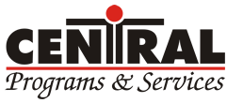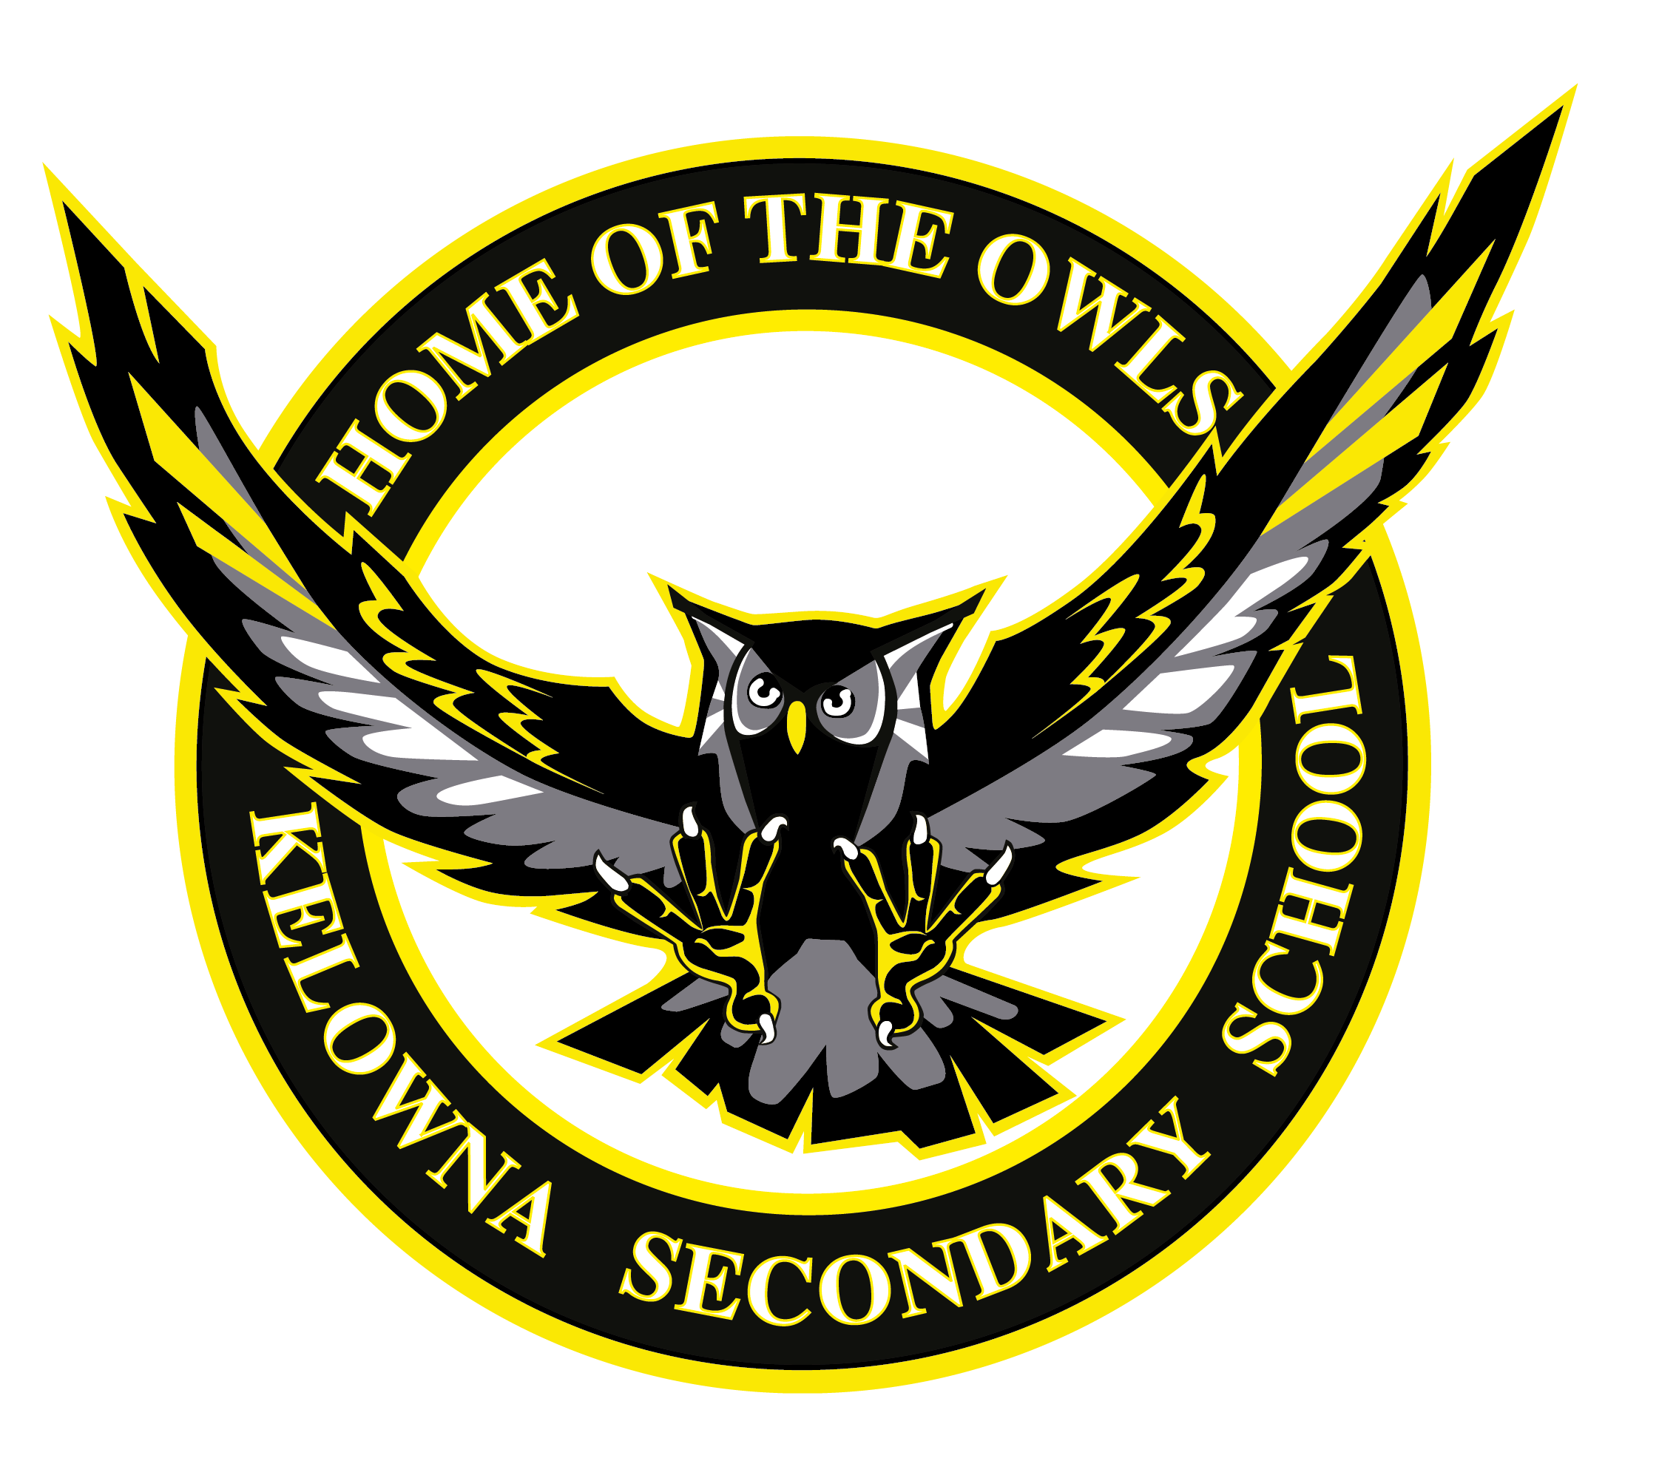

District Authority Scholarships will be distributed to selected graduating students who excel in, and plan to pursue a career in any of the following skill areas:

- Indigenous Languages and Culture (demonstrated at school or in the community)
- Fine Arts (Visual Arts, Dance, Drama, Music)
- Applied Design, Skills, and Technologies (Business, Technology, Home Economics, Information Communication Technology)
- Physical Activity (Athletics, Dance, Gymnastics, etc.)
- International Languages (French, Spanish, German, ASL, etc.)
- Community Service (must be related to a career choice and show significant leadership initiative, organization, and commitment: including a demonstration of local and global issues)
- Technical and Trades Training (Carpentry, Automotive, Mechanics and Cook Training, etc.)

ASSESSMENT OF STUDENT APPLICATION
Each student must submit the following in their District Authority Scholarship application package. Each application will be initially assessed by a School-Based District Authority Scholarship Committee and then the application will be passed on to our District Authority Scholarship Committee, who will make the final selections.

Each application will be assessed using the following breakdown:

- Statements of Recommendation - 2 recommendations required 20 points
- Application Questions (reviewed as part of Interview Assessment) 20 points
- Interview Presentation (Video/Performance/Demonstration/Portfolio) 60 points
TOTAL: 100 points
APPLICATION DETAILS
- All District Authority Scholarship applications must be completed online.
- Please go to https://das.sd23.bc.ca and log in using your school district network credentials.
***Please be sure to save your application as you work through the process. If having difficulty, try using Firefox instead of Chrome.
- You will need your Ministry ID (PEN) to complete the application.
- You must be a Canadian Citizen and a permanent resident of British Columbia.
- You must be eligible to graduate in June, and you must graduate to receive an award.

Application Questions (20 Points)
The following application questions will be completed online as part of the application process and will be reviewed and scored by the District Authority Scholarship Interview Panel.

Question 1. (200 words max)…Why would you be a good District Authority Scholarship candidate? Be clear and concise. Convince the committee that you are worthy of this scholarship.

Question 2. (200 words max)… The connections between your abilities and your career goal. Specifically address how your skills and experiences match your career goal! You can do this by highlighting any contributions you have made, or leadership roles you have taken on, either in the community and/or at school. You could also highlight any related extra-curricular activities that you are involved in. Remember, you are highlighting and interpreting your resume, not repeating it.

Question 3. (200 words max)... You must also clearly address the School District's goal for students to demonstrate the Attributes of a 21st Learner (see Appendix A for clarification of the Attributes of a 21st Century Learner). Please describe in detail, your strongest attribute, and provide evidence of how you demonstrate and exemplify this attribute. Describe how this attribute relates to your career pathway.

Support each statement you make with a piece of evidence (see Appendix B for examples of “great” evidence that you could use to support your statements). Try to use several shorter paragraphs or bullets rather than one large block of text.

Question 4. (100 words max)… Thank the committee for considering you as a candidate.

Statements of Recommendation (20 Points – 10 points per recommendation)
The student must select two adults, associated with the school district, to complete an online confidential Statement of Recommendation. Selected adults will be contacted via email as part of the online application process. One recommendation must be from the selected ‘skill’ area being demonstrated by the applicant.

Interview Presentation (60 Points)
An interview presentation with a skill demonstration is the major focus of the application process. Each student will be assessed by presenting a Video, Performance, Demonstration, or Portfolio. While, students may select a presentation format that best suits their personality and skills, the presentation must be made in front of a Scholarship panel.

Interview Preparation Guide
To be successful in your application, you must demonstrate that you are "ready" and have the character skills to pursue, and to be successful in your post-secondary transition.

The interview must include the following:
  - 5 - 10 minute demonstration of your skill - remember to provide theoretical knowledge of the particular skill area you are applying for (using appropriate technical language).
  - What are your short and long term education and career goals?
  - What have you done in the last few years to prepare for these goals?
  - Tell us about a time when you had to persevere, despite obstacles in your life or in your chosen skill area
    - How did you get through this challenge?
    - What did you learn from this experience?
    - How has it lead you to be successful in your chosen skill area?
  - What community and/or extra-curricular activities have you participated in recently?
  - What activities do you foresee yourself being involved with in the future?
  - Highlight with evidence, one or two of your strongest attribute(s) that you would like to share with us.
  - How do your attributes reveal learning and reflection?

APPENDIX A - The School District’s Attributes of a 21st Century Learner

Learner: Engaged, resilient and seeks to understand through:
- Literacy, Numeracy and Subject Competencies
- Information, Media, and Technology Literacy
- Self-Direction, Work Ethic, and Accountability
- Healthy Lifestyle
- Financial Literacy
- Consistency and Commitment
- Resiliency and Perseverance
- Willingness to Learn

Thinker: Analyzes, makes connections, inferences, asks questions, and transfers knowledge through:
- Critical Thinking and Problem Solving
- Open Mindedness and Reflection
- Flexibility and Adaptability
- Personal Awareness and Responsibility
- Interpersonal Skills (Confidence, Patience)
- Positive Personal Identity

Innovator: Sees possibilities and generates original ideas with value through:
- Curiosity and Imagination
- Creativity, Design and Performance
- Initiative and Entrepreneurship

Collaborator: Excels at working with others to create new understanding through:
- Appreciating Diversity
- Effective Communication
- Interdependence
- Relationship Building

Contributor: Participates in the local and global community through:
- Finding, Following, and Sharing Passions
- Respect, Empathy, and Kindness
- Integrity and Ethical Behaviour
- Civic and Environmental Responsibility
- Embracing Diverse Cultures and Lifestyles

APPENDIX B - Supporting Evidence Suggestions

- Individual Schoolwork/Classwork | - Personal Accomplishments
- Class/Group Projects | - Personal Artifacts
- Report Card/Transcripts | - Newspaper/Published Articles
- Photographs | - Community Recognition
- Earned Credentials | - Proof of Post-Secondary Enrolment
- Key Learning Experiences Journal | - Proof of Employment
- Scrapbook | - Employment Appraisals
- Resume | - Work Experience/Job Shadows etc.
- Extra-Curricular Work | - Awards/Certificates
- Letter of Reference/Video Clip from Teacher/Employer/Credible Adult | - Conversation/Story

